JWTD Assignment-5

Name: Siddhi Shenoy

RollNo: 231047018

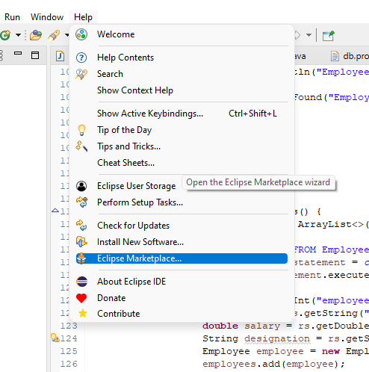

Search for: web application

Install the following

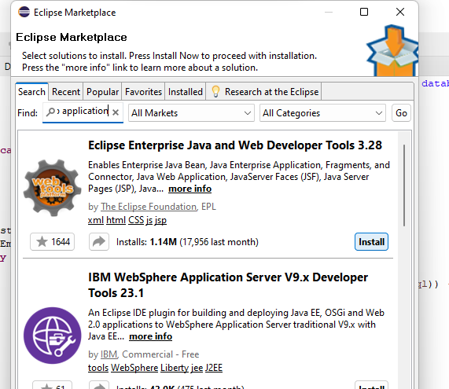

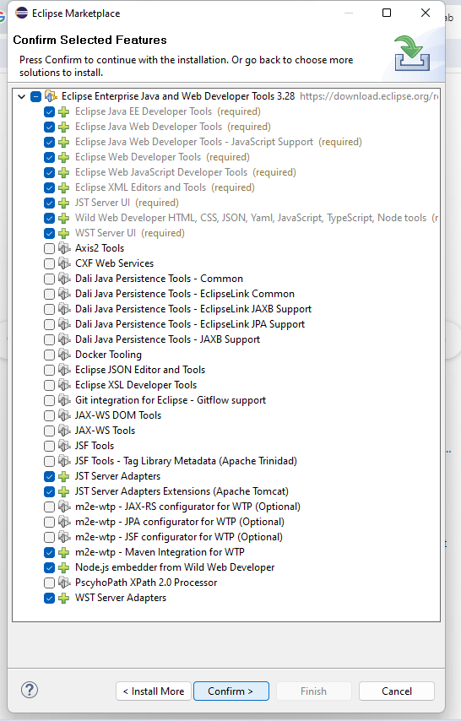

Click confirm. On the license page, click on I accept and then click Finish.

Wait for the software to get installed.

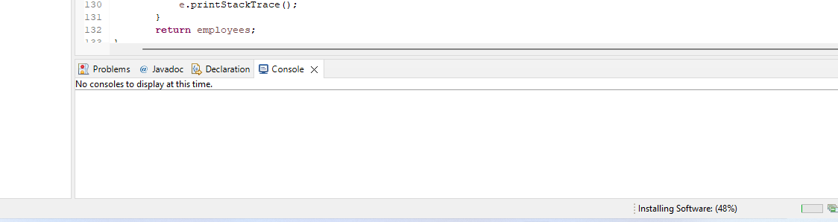

Restart eclipse once its installed.

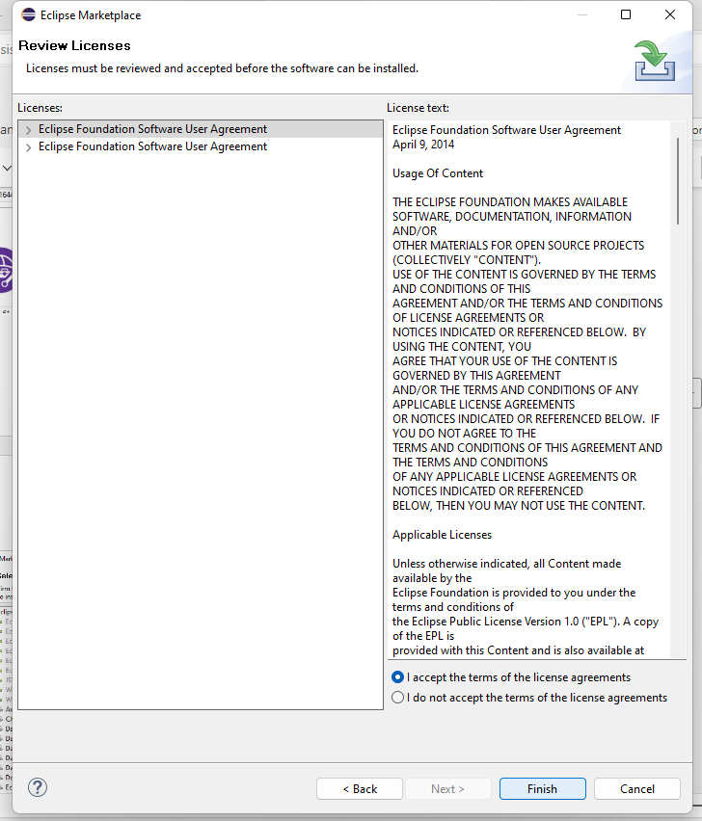

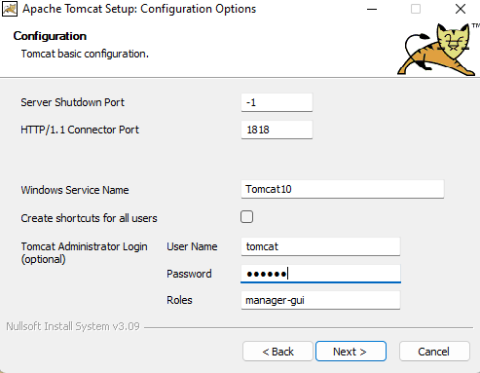

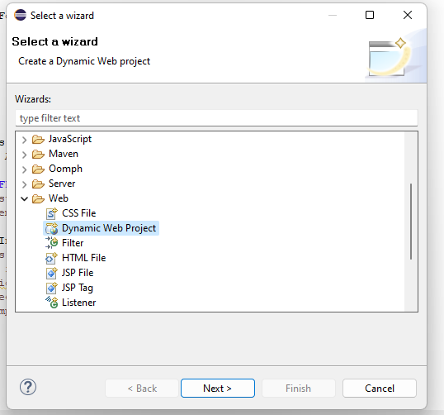

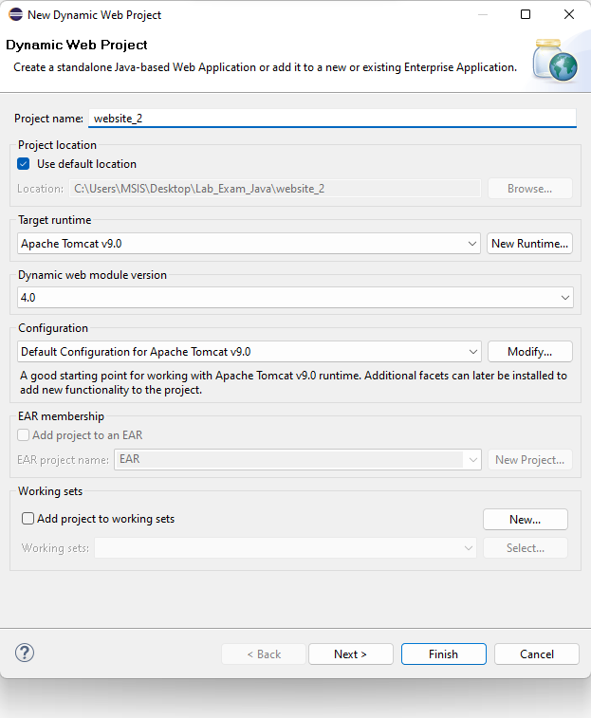

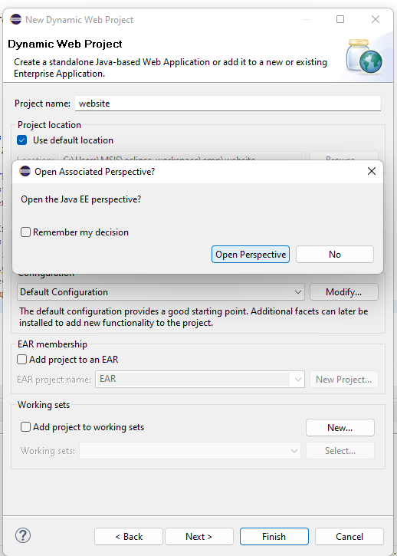

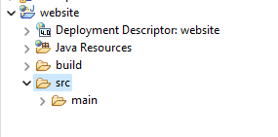

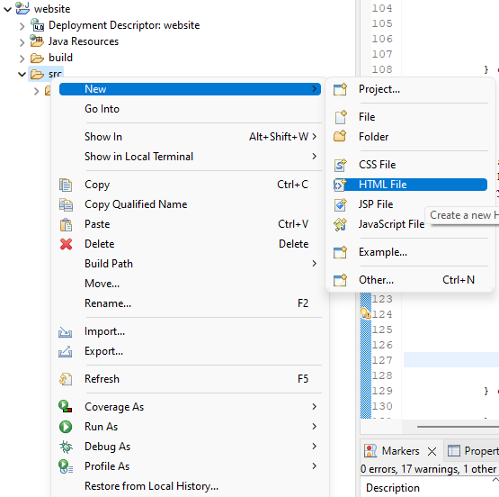

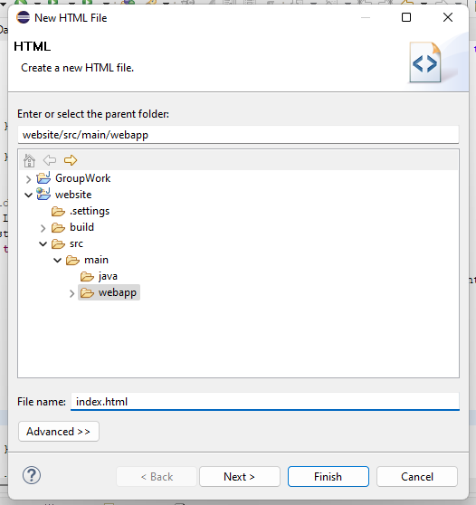

Html

<!DOCTYPE html>

<html>

<head>

<meta charset=*"ISO-8859-1"*>

<title>Trial Website</title>

</head>

<body>

<h2>Welcome to my first website!</h2>

<p>Siddhi here.</p>

</body>

</html>

Click on the ‘Click this link to create....’

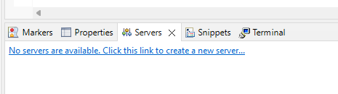

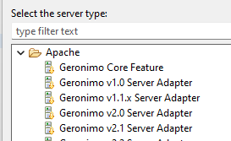

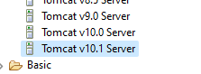

Click on next. Browse the file that you want to download and install tomcat.

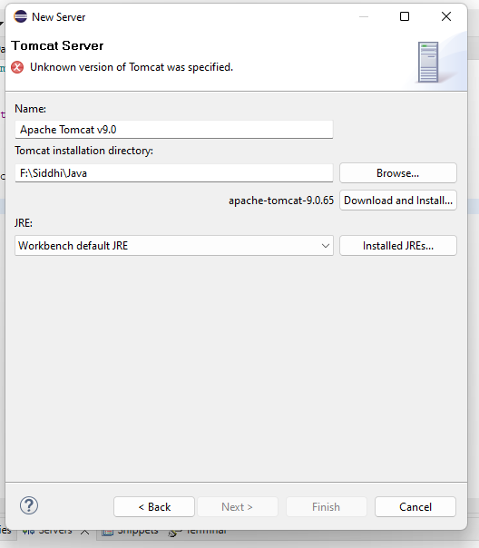

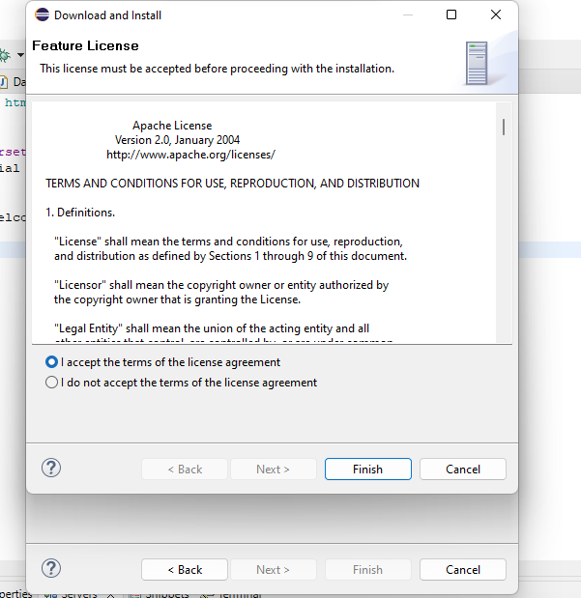

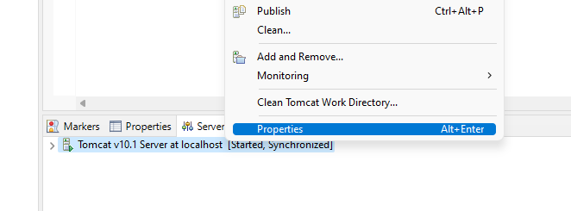

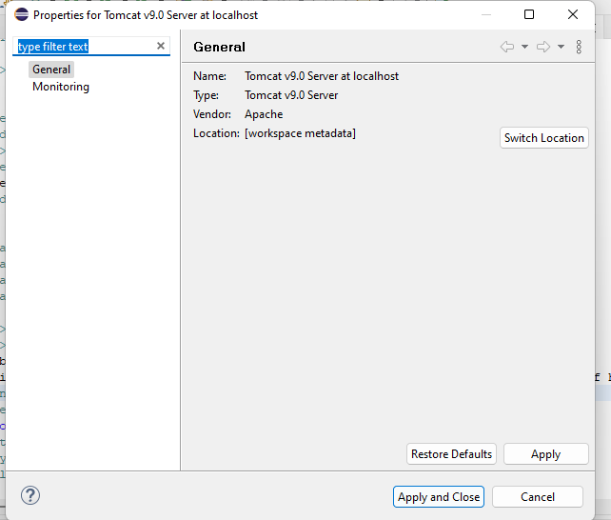

Click on switch location

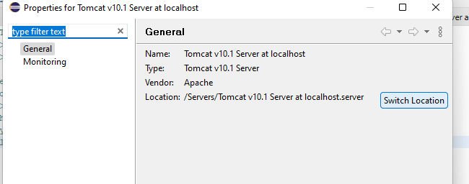

Apply and close.

Double click on tomcat under the server tab. Click on Use Tomcat installation. 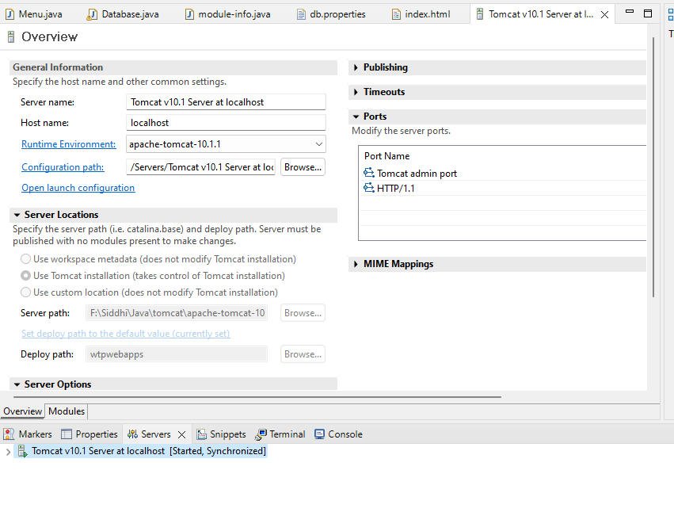

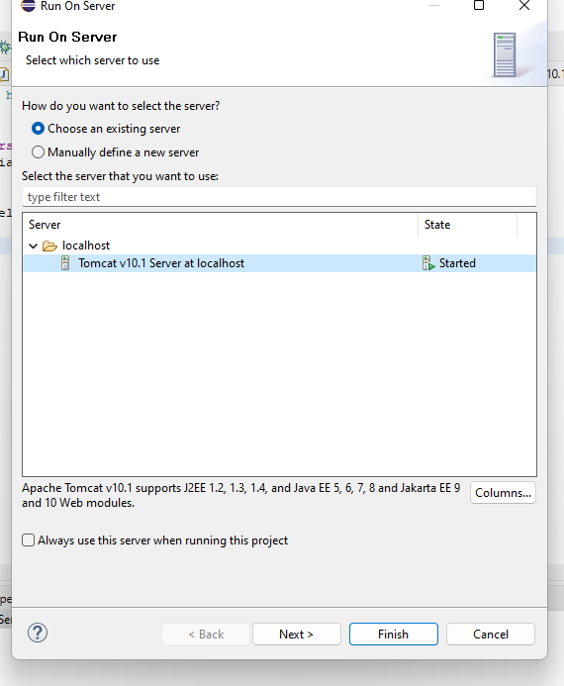

Then go to the index.html code and run it. Run on server. It will ask if you want to restart the tomcat. Restart and run.

